

Pre- Appointment Questionnaire

**Welcome to PLM Financial group**

To help you prepare for our upcoming meeting, we have created this pre-appointment fact find to guide you through the process we use to give financial advice.

The bulk of this booklet helps us gather information about your financial life. We will need:

* An estimate of your income and expenses. One of the best ways of gathering this information is through our simple budget planner. This is included on pages 3 to 4.
* We will need to understand what you owe and what you own. Your assets and liabilities can be identified on page 5.
* A number of documents, such as life policies and investment schedules will help us plan your financial future. A checklist is included on page 6 to make sure nothing is missed out.
* I am also keen for you to reflect on your financial goals – simply what it is that you want to achieve? We will discuss this in more detail when we meet.

Financial advice is best addressed in a holistic way – that is, by looking at all of your financial matters together, rather than addressing one or two issues in isolation. Page 2 of this booklet talks a little more about the planning process and what you can expect.

I look forward to our meeting. Don’t forget to bring all the necessary documents and this booklet with you.

Yours sincerely,

Andrew Price  
CFP® LRS® F Fin MAppFin GDipFinPlanning

FPA logo

Financial advice - what you can expect

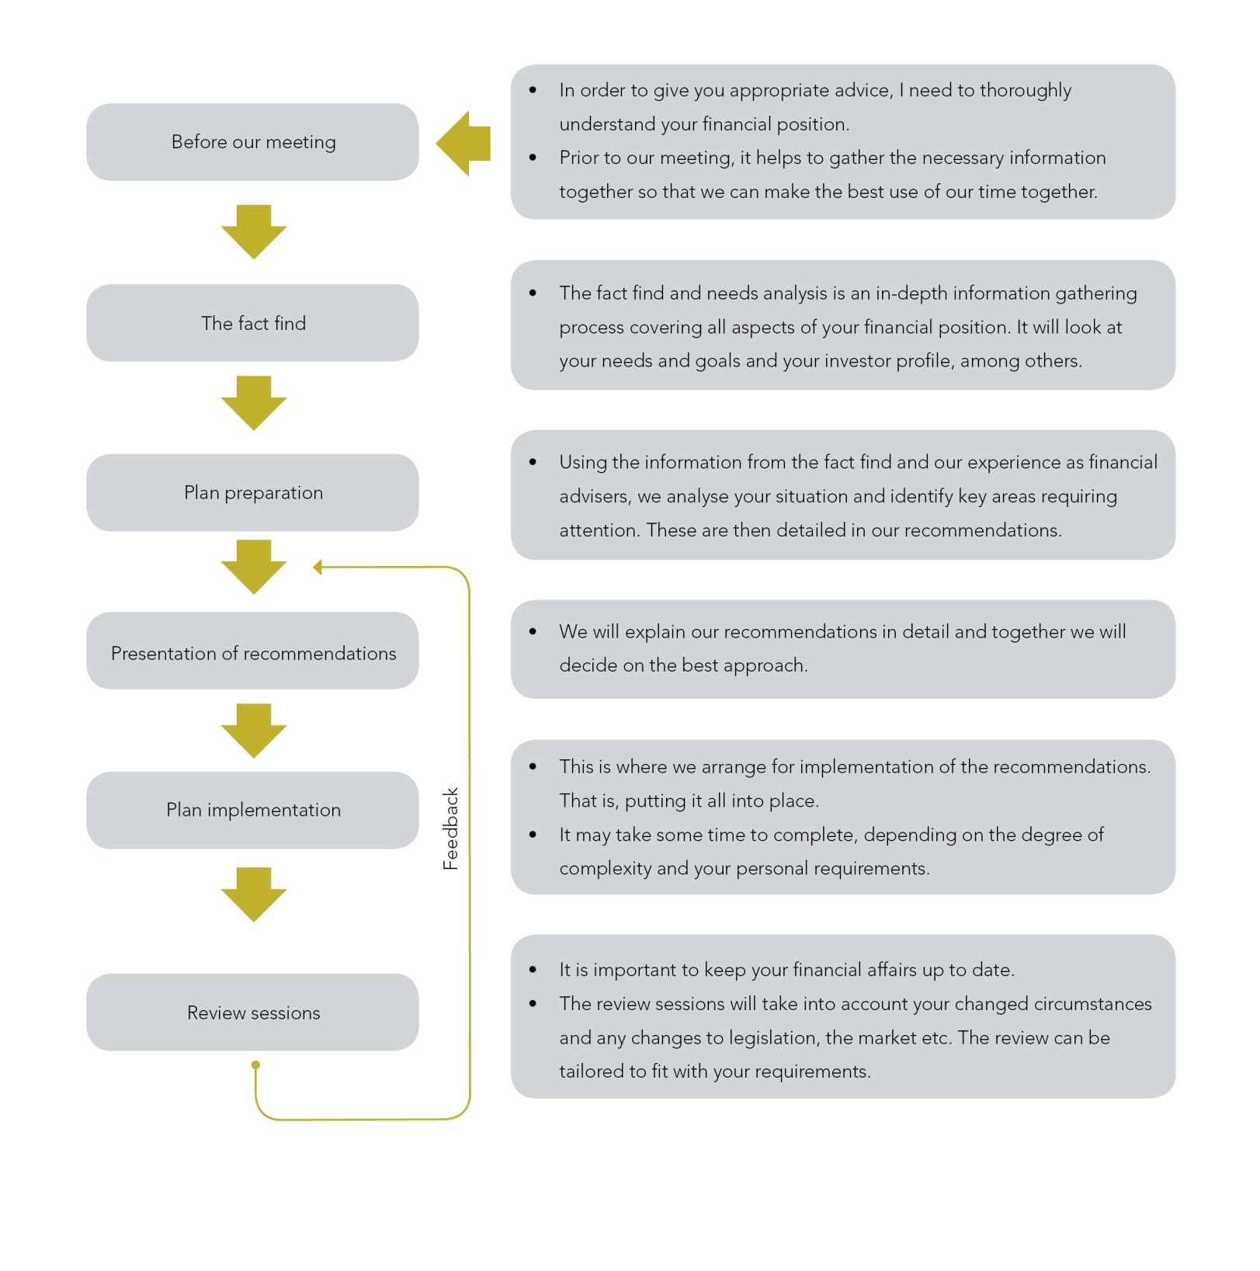Personal financial management starts and ends with your needs. In developing your financial plan, we use a step by step process - starting with the gathering of information, through to the preparation and implementation of recommendations. We also commit to reviewing your financial affairs on an ongoing basis.

Personal Details

|  |  |  |
| --- | --- | --- |
| Client (1) |  | Client (2) |
| Title: |  | Title: |
| Surname: |  | Surname: |
| Given names: |  | Given names: |
| DOB: / / |  | DOB: / / |
| Address: |  | Address: |
|  |  |  |
| Phone: |  | Phone: |
| Fax: |  | Fax: |
| Mobile: |  | Mobile: |
| Email: |  | Email: |

Budget planner

Putting together a budget can seem tedious and time consuming, but gaining a good understanding of your income and ongoing expenses is an important part of the overall planning process.  
  
The following table was developed to come up with a reasonable estimate of your spending patterns, and is suitable to begin the financial planning process.  
  
Some of the line items will be easy, while others will require a bit of thinking or looking up of past records.

Income (Money In)  
**Earned income**  Client Partner Notes

Gross salary/wages

$

$

Bonuses/commissions/profit share   
  
**Investment income**

$

$

$

$

$

$

Rents

Investment income - shares/units trusts

Interest on deposits

$

$

**Earned income** Client Partner Notes

Social security benefits

Centrelink

$

$

$

$

$

$

$

$

Other

**Other income**

Pension/Annuity Income

Total annual income

Expenses (money out)

Monthly Annual Notes Expenditure Expenditure

**Food and health**  
Food and drink

$

$

$

$

Private health fund/insurance

$

$

$

$

Doctor/dentist

Optician/chemist

**Personal**

$

$

$

$

$

$

$

$

$

$

$

$

$

$

$

$

$

$

$

$

$

$

Clothing

Hair/cosmetics

Entertainment

Holidays

Childcare

Sports/hobbies

Subscriptions and membership

Gifts (birthdays/Christmas etc.)

**Educational**

School fees/courses

Uniforms/excursions/books

Courses

Monthly Annual Notes   
 Expenditure Expenditure

**Transport**

$

$

$

$

$

$

$

$

$

$

$

$

$

$

$

$

Car payments (loan/rego/insurance)

Running costs (petrol/services/repairs)

Parking/tolls

Public transport/taxis

**House**

Mortgage/rent/land tax

Rates (water/council/body corp)

Insurance (building/contents)

Maintenance (cleaning/garden/repairs)

**Services**

Electricity and gas

$

$

$

$

Telephone (internet/home/mobile)

**Finance**

$

$

$

$

$

$

$

$

Personal loan payments

Credit card payments

Life and disability insurance

Superannuation

**Other**

$

$

Total living expenses

Assets and liabilities

Estimated Amount owing Owner* Notes

market value

**Property and contents**

$

$

Private residence

$

$

$

$

Land or other real estate

$

Home contents

$

Collectables/valuables

**Investments**

$

$

$

$

$

$

$

$

Share portfolio

Superannuation

Life policies (Surrender value/loans)

Bank/credit union etc.

$

$

$

$

Deposits

Credit cards/store cards

**Transport/leisure**

$

$

$

$

Motor vehicles

Boat/caravan/motorcycle

$

$

**Other**

$

$

**Total assets**

**Total liabilities**

**\*S-Self; P-Partner; J-Joint**

List of documents

The advice we provide is only as good as the quality of the information on which it is based. Part of my role is to gain a good understanding of your personal situation so that we can tailor our recommendations to your needs and requirements.  
  
Please go through your papers and assemble as many of the following documents as possible for our meeting. It will help us make the best use of our time together.

**Investments**

Details of any personal and employer superannuation or eligible termination payments (ETPs)

Managed funds, including unit trusts

Direct investments, including shares, investment properties etc.

**Cash Flow**

Income and expense details

**Insurance**

Insurance details, including life insurance, health insurance, your home, motor vehicle and business insurance

**Tax and social security**

Information about your mortgage and investment debt

**Debt position**

Information about your taxation position and any social security entitlements/claims

**Estate**

Wills, trusts and powers of attorney

 Policy schedules □

 Planned summaries □

 List of key assets □

 Listing of shareholdings □

 Valuations of assets (eg. property) □

 Latest budget (refer to the budget summary) □

 included in this booklet) □

 Life insurance policies/schedules □

 General insurance policies □

 Business insurance policies □

 Copy of your latest tax return □

 Social security details (if any) □

 Current value of outstanding mortgages □

 Value of investment debt and repayments □

 Confirm location of your Will □

 Bring a copy of your Will □

Your financial goals

Clearly identifying your personal goals will help with the development of your financial plan.  
  
While these are often of a personal nature, they almost always have financial implications and need to be factored in.  
  
While we will be exploring your goals in more detail later, it may be helpful if you could give some advance thought to the matter. Try the following format. It is a way of clarifying what you want prior to our meeting.

Timeframe Things you want to achieve/goals

Short term goals up to 3 years

Medium term goals 3 to 7 years

(eg. travel, renovations etc.)

Long term goals 7 years and over

(retirement?)

The best goals are ones that are clear, unambiguous and measurable - but most of all realistic and achievable.

Some typical goals would be:

* To have $10,000 available every 3 years to be able to travel internationally.
* To have sufficient assets at retirement (age 60) to be independent of social security payments.
* To own my own home and have an investment portfolio worth $500,000 at retirement at age 60.
* To pay for the children’s secondary education at private school.

Things to do / additional notes

|  |
| --- |
|  |
|  |
|  |
|  |
|  |
|  |
|  |
|  |
|  |
|  |
|  |
|  |
|  |
|  |
|  |
|  |
|  |
|  |
|  |
|  |
|  |
|  |
|  |
|  |

*The purpose of this booklet is to provide information as opposed to advice. If you have a need for financial or other advice you should seek advice rather than rely on the information in this booklet. This is because the advice you receive may vary depending on your individual circumstances and the laws that change from time to time.*

*Please refer to our Privacy Statement which is contained in our Financial Services Guide (FSG).*



Our commitment to you

We aim to deliver excellent advice and service to you today. We also commit to providing new advice as your needs and circumstances change. If you have a comment or suggestion about how we can deliver an even better service to you, please share it with us.

Most of our clients discover us by word of mouth which means they like our services enough to tell their family and friends. This is the ultimate compliment we can receive. It is these personal recommendations that have allowed us to build a reputable business based on long lasting client partnerships.

If you have friends or business associates who would be interested in our services, please let them know about us. We would be delighted to assist them too.